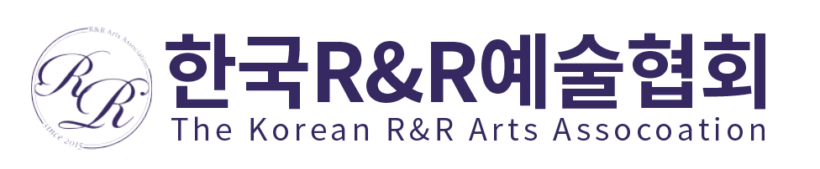

2020 The 1st R&R Art Association International Art Competition for Children _ Entry_Form

(Must be English)
Name : |  | Photo
Affiliation(School) : |  | Photo
National : |  | Photo
Age : |  | Photo
Address (include postal code)

E-mail : | Tel :
a brief summary of your career (5 lines) or Introduction

*** If you are a foreign applicant, please scan your piece and send an email to 815rabbit@hanmail.net

I agree with the terms and condition for applying The 1st R&R Art Association International Art Competition for Children.

2020. . .

Applicant (Signature)

